CURRICULUM VITAE

|  |  |
| --- | --- |
| **PERSONAL DATA** | |
| ***Name*** | ***Ronny Tuwolambung*** |
| *Place/ Date of Birth* | *Manado* |
| *Rank* | *AB* |
| *Religion/Marital Status* | *Christian/Married* |
| *Height/Weight* | *160 cm/73 kg* |
| *Nationality* | *Indonesian* |
| *Home Address* | *North Kombos Env. No IV*  *Manado City, North Sulawesi* |
| *Mobile Number* | ***+62 81277204051*** |
| *Email Address* | *Ronny30Tuwolambung.@Gmail.com* |

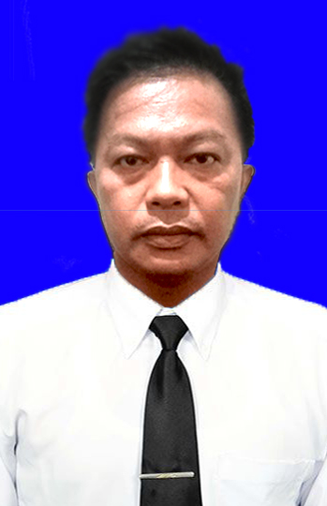

|  |  |  |  |  |  |
| --- | --- | --- | --- | --- | --- |
| **TRAVEL DOCUMENT** | | | | | |
| **Document** | **Number** | | **Place, Date of Issued** | | **Expire Date** |
| *Passport* | *E 3656887* | | *Manado, 08 Aug 2023* | | *31 Aug 2033* |
| *Seaman Book* | *D 073746* | | *Bitung, 2018 March 2018* | | *03 Juni 2020* |
| **CERTIFICATE OF COMPETENCY** | | | | | |
| **Certificate Type** | | **Number** | | **Place, Date of Issued** | |
| *Deck Officer Class-V* | | *6200263251n50211* | | *BP3IP Jakarta, 11 October 2011* | |

|  |  |  |
| --- | --- | --- |
| **CERTIFICATE OF PROFICIENCY** | | |
| **Certificate Type** | **Number** | **Place, Date of Issued** |
| *Basic Safety Training* | *6200263251010108* | *Bina sena Jakarta 05 maret 2008* |
| *Proficiency in Survival Craft and Rescue Boats* | *6200263251040108* | *Bina sena Jakarta 10 Maret 2008* |
| *Advanced Fire Fighting* | *6200263251061114* | *Bina sena Jakarta 16 May 2014* |
| *Medical First Aid* | *6200263251071114* | *Bina sena Jkarta 16 May 2014* |
| *Security Awareness Training* | *6200263251310214* | *Bp3ip Jakarta,20 Januari 2014* |
| *Seafarers with Designated Security Duties* | *6200263251320214* | *Bp3ip Jakarta,21 Januari 2014* |

SEE NEXT PAGE FOR SEA SERVICE EXPERIENCE

|  |  |  |  |  |  |  |  |  |
| --- | --- | --- | --- | --- | --- | --- | --- | --- |
| **SEA SERVICE RECORD** | | | | | | | | |
| **NO** | **Vessel Name** | **Vessel**  **Type** | **Rank** | **GRT**  **BHP** | **Flags**  **Register** | **Sing On**  **Sign Off** | **Company** | **Trade Area** |
| 10 | ***CAPTAIN JOHN K*** | *AHTS* | *A/B* | *1745*  *5150* | *Marshall*  *Islands* | *01.01.2023*  *01.06.2023* | *Berlitz*  *Offshore* | *CARI GALI*  *Malaysia* |
| 09 | ***LANPAN 31*** | *AHT* | *A/B* | *1200*  *7230* | *Singapore* | *01.06.2018*  *01.03.2019* | *Lanpan*  *Offshore* | *ADNOC*  *UAE* |
| 08 | ***Jubilee*** | *Tangker* | *A/B* | *1822* | *Singapore* | *20.05.2016*  *18.05.2017* |  | *Singapore* |
| 07 | ***KM Smi 3*** | *Kargo* | *2/O* | *1290* | *Indonesia* | *16.05.2014*  *05.06.2014* |  | *Indonesia* |
| 06 | ***Quinta*** | *Tangker* | *A/B* | *5738* | *SINGAPORE* | *04.09.2013*  *27.10.2013* |  | *SINGAPORE* |
| 05 | ***TB Mitra 210*** | *Tag bot* | *2/O* | *662* | *Indonesia* | *26.01.2013*  *04.09.2013* |  | *Indonesia*  *Water* |
| 04 | ***TB Nusantara 01*** | *Tag boat* | *2/O* | *183* | *Indonesia* | *15.03.12*  *26.01.13* |  | *Indonesia*  *water* |
| 03 | ***MV Guang Rong*** | *Kargo* | *A/B* | *5264* | *Singapore* | *12.08.2008*  *18.09.2010* |  | *Singapore*  *water* |
| 02 | ***TB TarahanJaya*** | *Tag Boat* | *A/B* |  | *Indonesia* | *10.07.2005*  *09.09.2006* |  | *Indonesia*  *Water* |
| 01 | ***TB Bidadari*** | *Tag Boat* | *A/B* |  | *Indonesia* | *08.04.2003*  *04.12.2003* |  | *Indonesia*  *water* |

Sincerely Yours



RONNY TUWOLAMBUNG